What is power BI

BI is nothing but a business intelligence

BI contains multiple tools in which we are going to use power BI tool

It consists of lots of processes in which we are going to use ETL (Extract, Transform, Load)

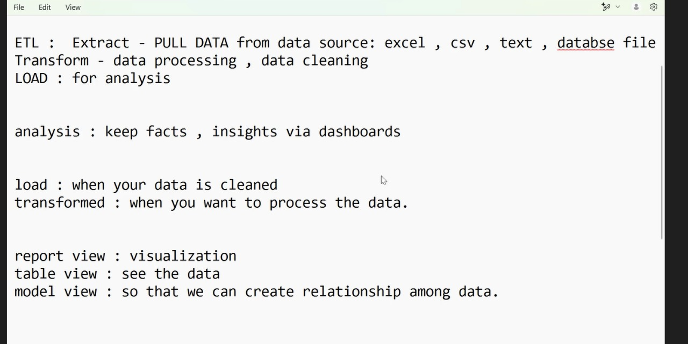

Steps involved in power BI desktop

Step 1: Open power BI desktop now click on blank report next click on Get Data. Below it contains several files format to insert dataset in it

Step 2: we have chosen CSV/Text file now insert the CSV file in it

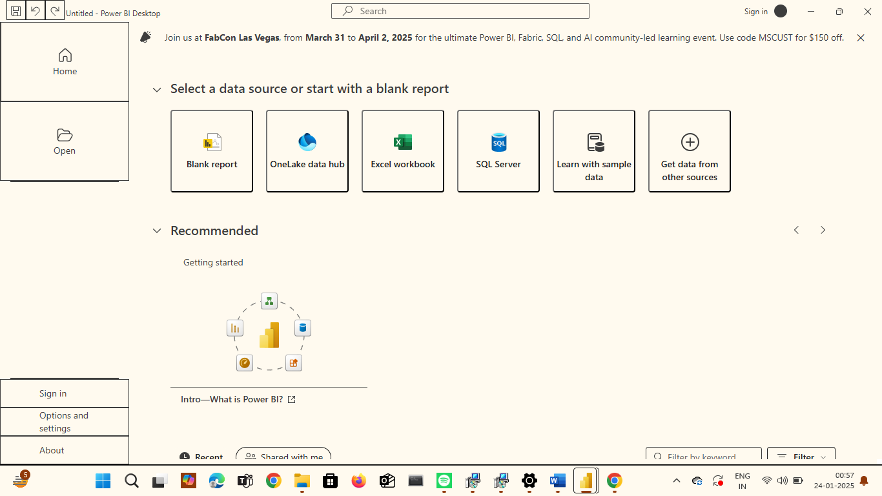

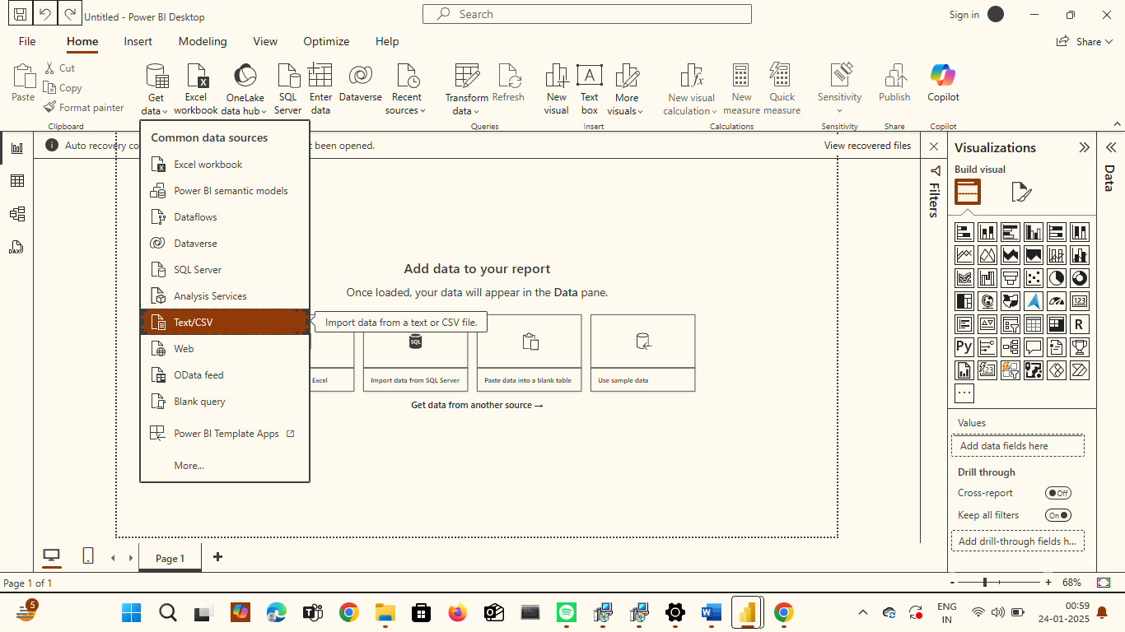

Step 3: After that we have to press load the data

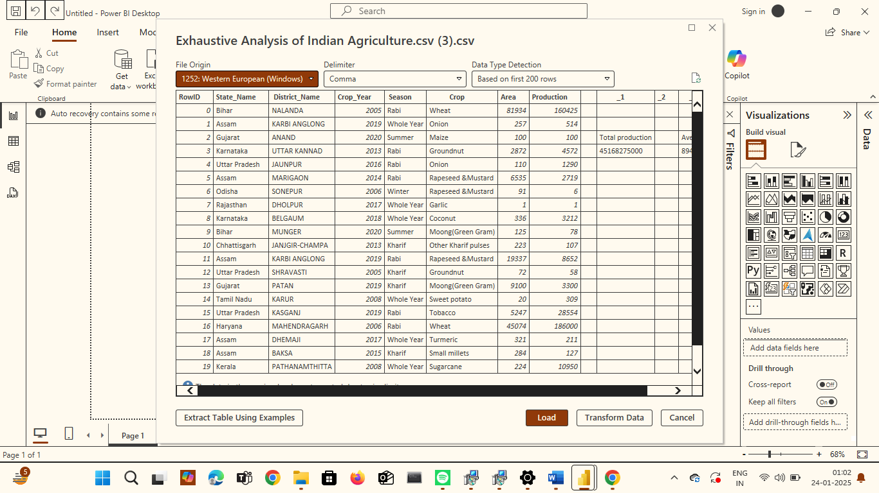

The dataset has been successfully uploaded

Step 4: To perform data cleaning we need to press on transform data a new tab will be opened called as power query editor where we can perform several operation

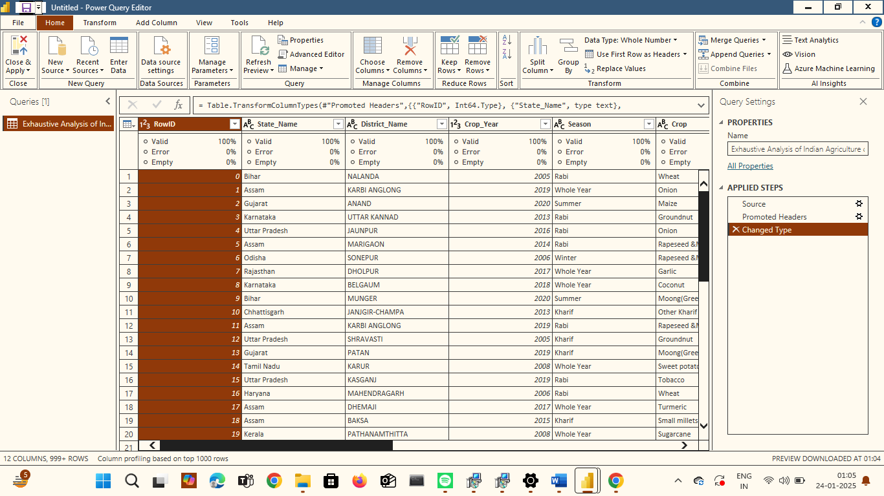

Step 5: Next we can able to remove irrelevant columns by right clicking on the title of the particular column that you want to remove next click on the remove option

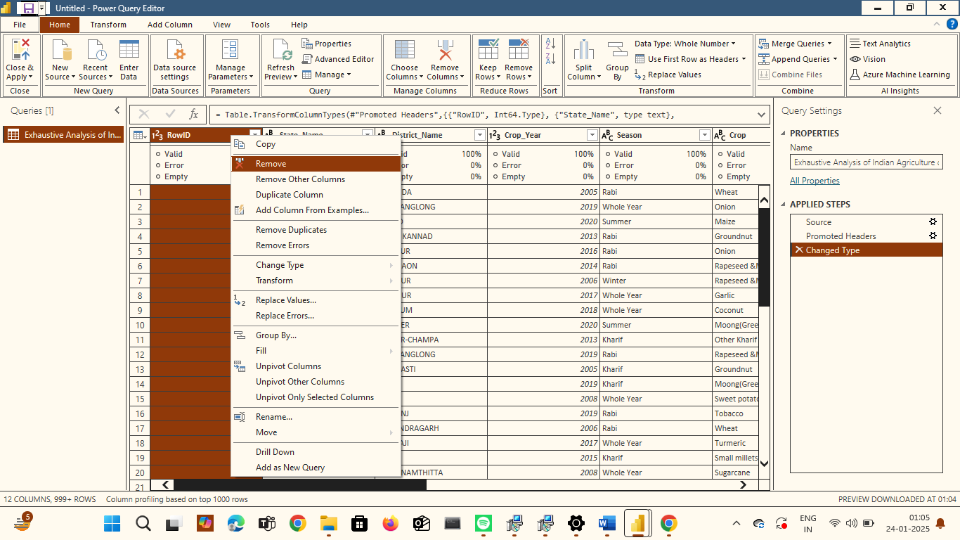

Step 6: To check of any duplicate , error or empty rows click on view where you can see column quality click .In this dataset there are no error ,empty rows so the value will be 0

Step 7: if there was an empty row present then click on the remove rows option where you can remove the rows as shown below

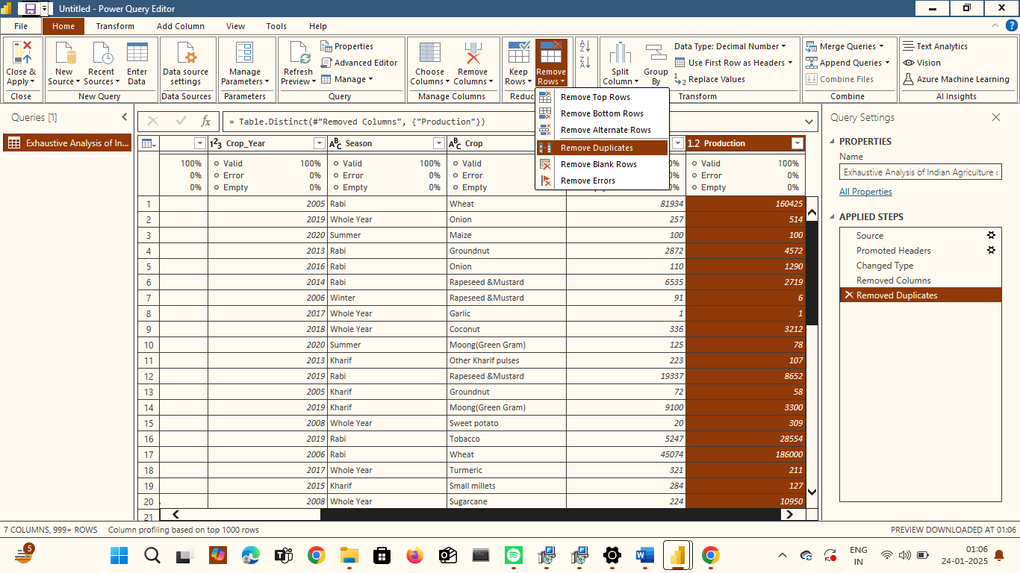

Step 8: After performing all these steps click on close & apply to apply all the changes and then save the file as shown below

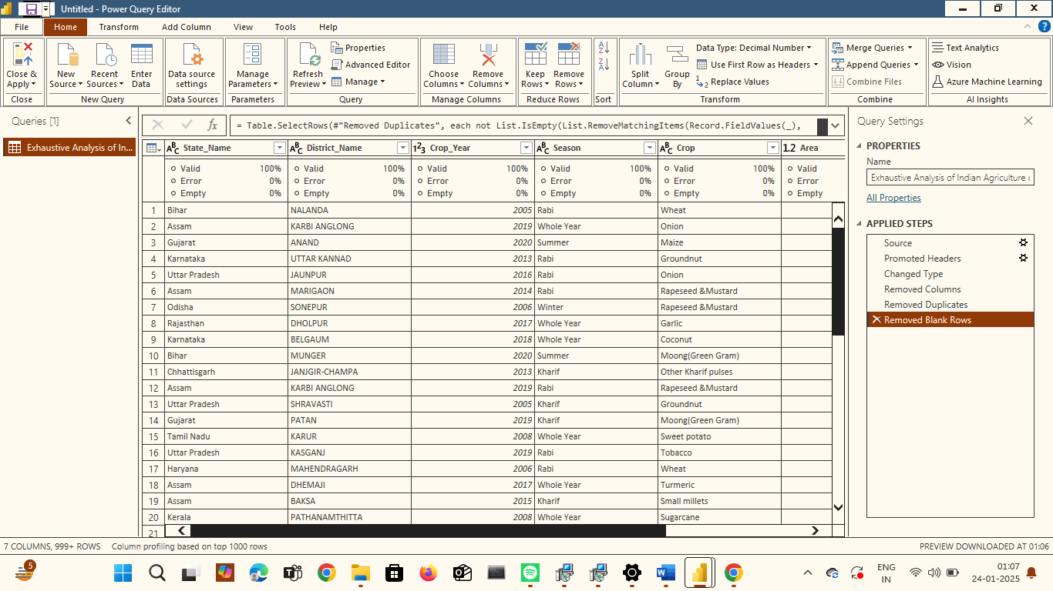

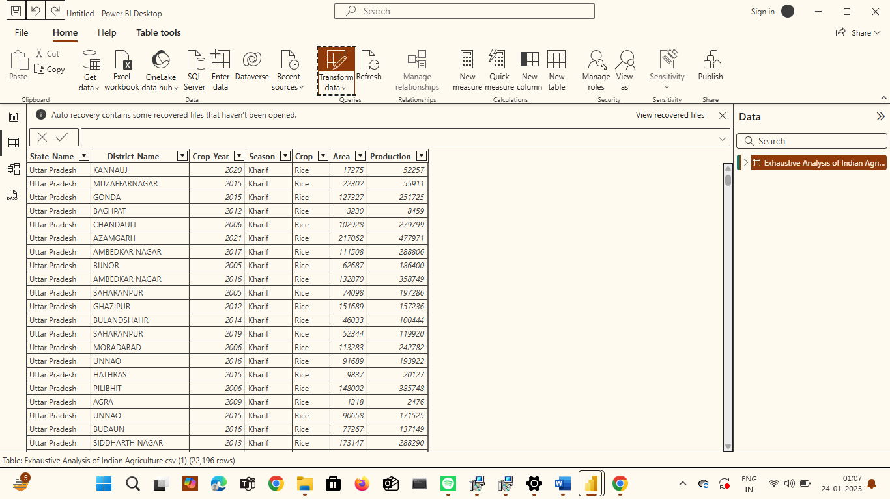

We can clearly see that all the unnecessary column has been deleted as we made some changes in the dataset and saved the file.